

Practices for Secure Software Report

Table of Contents
Document Revision History 3
Client 3
Instructions 3
Developer 4
1. Algorithm Cipher 4
2. Certificate Generation 4
3. Deploy Cipher 4
4. Secure Communications 4
5. Secondary Testing 4
6. Functional Testing 4
7. Summary 4
8. Industry Standard Best Practices 4

Document Revision History

Version | Date | Author | Comments
1.0 | 2/16/2026 | Esther Castaneda

Client



Instructions

Submit this completed practices for secure software report. Replace the bracketed text with the relevant information. You must document your process for writing secure communications and refactoring code that complies with software security testing protocols.

- Respond to the steps outlined below and include your findings.
- Respond using your own words. You may also choose to include images or supporting materials. If you include them, make certain to insert them in all the relevant locations in the document.
- Refer to the Project Two Guidelines and Rubric for more detailed instructions about each section of the template.

Developer
Esther Castaneda

Algorithm Cipher

For Artemis Financial’s application, SHA-256 was selected for checksum verification
and TLS (Transport Layer Security) was implemented for secure communications. SHA-
256 generates a 256-bit hash value used to verify data integrity. It ensures that even a
small change in input data results in a completely different hash output, protecting against
tampering.
TLS secures communication between client and server using asymmetric encryption
during the initial handshake and symmetric encryption for ongoing communication. This
layered encryption approach protects sensitive financial data from interception.
Older algorithms such as MD5 and SHA-1 are no longer considered secure due to
collision vulnerabilities. SHA-256 and modern TLS configurations follow current
industry best practices and provide strong protection.

Certificate Generation
A self-signed certificate was generated using the Java keytool utility. A 2048-bit RSA
key pair was created and stored in a PKCS12 keystore file named keystore.p12. The alias
ssl-server was used for identification within the keystore.
The certificate was exported as a CER file for verification. This certificate enables
HTTPS communication within the application.
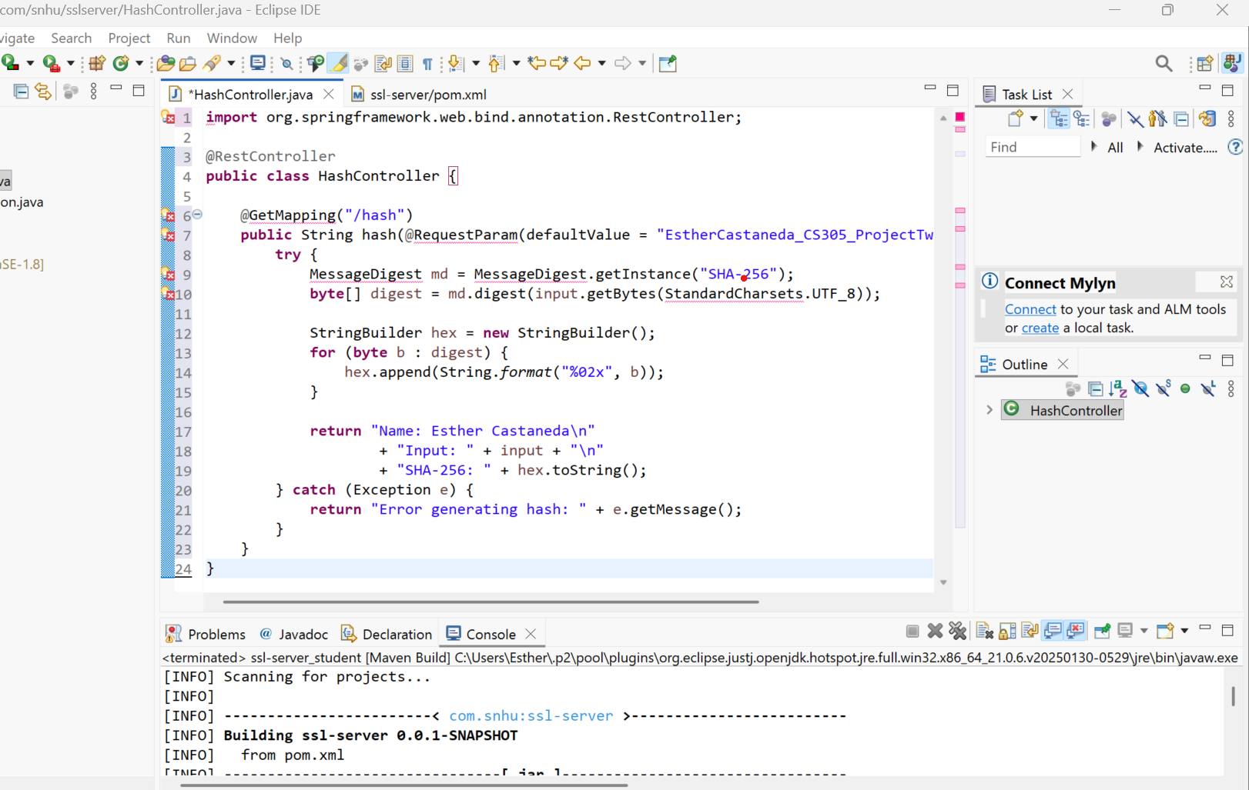

Deploy Cipher
The application was refactored to implement SHA-256 hashing for checksum
verification. A unique string containing my name was used to verify functionality. The
system successfully generated a 256-bit hash output, confirming that checksum
verification works properly.
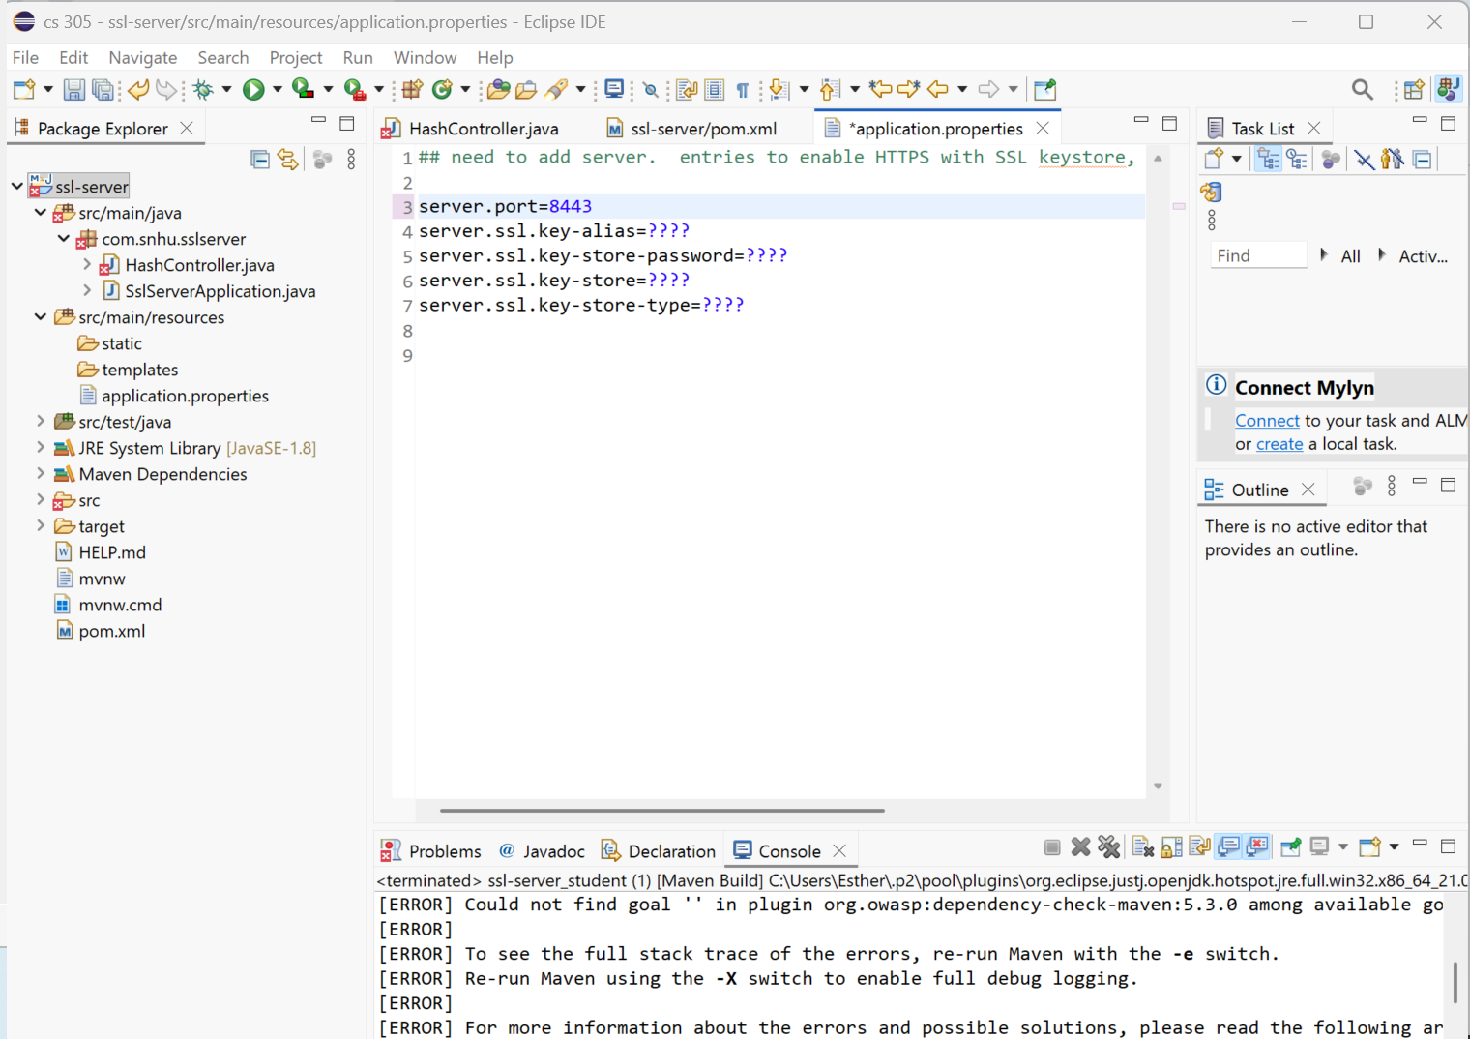

Secure Communications
HTTPS was enabled by configuring application.properties to use port 8443 and
referencing the keystore file. Once configured, the application successfully launched

using HTTPS. The browser displayed a secure connection when accessing
https://localhost:8443/hash.

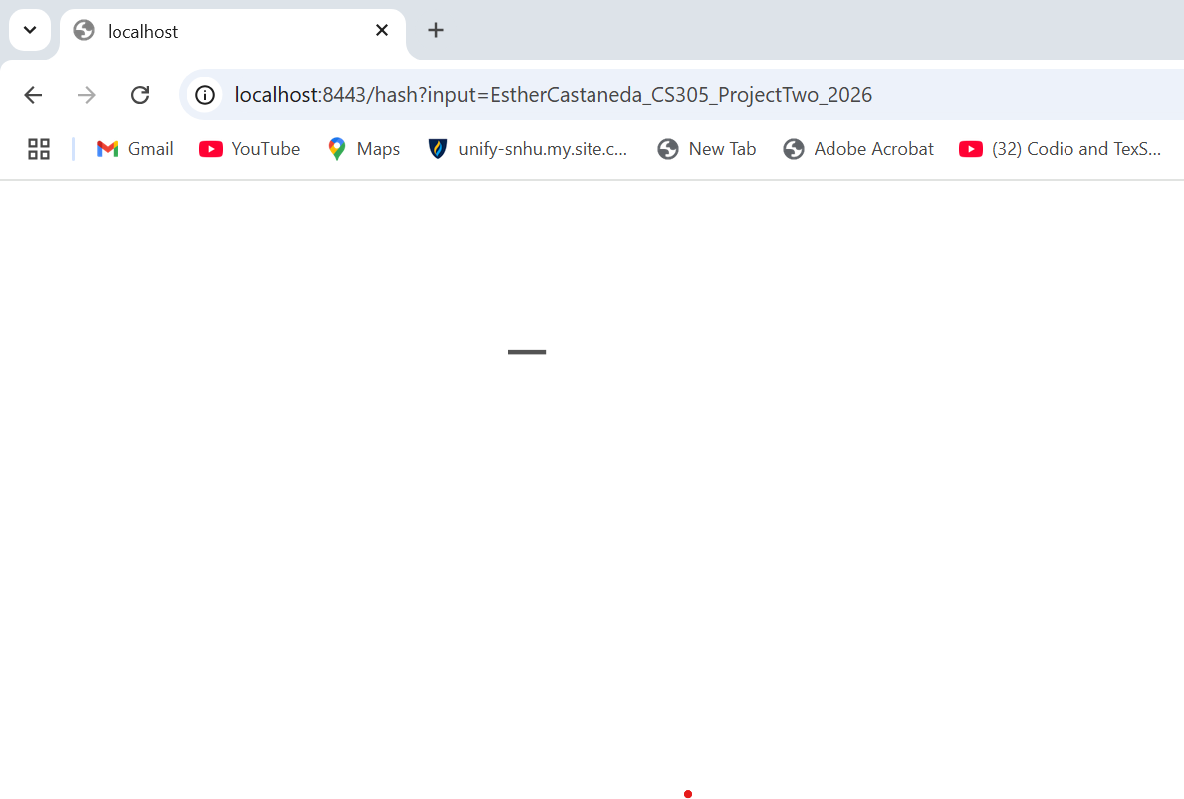

Secondary Testing
The OWASP dependency-check Maven plugin was integrated into the project to perform
static analysis of dependencies. The tool was executed to identify potential known
vulnerabilities. No additional vulnerabilities were introduced during the refactoring
process.

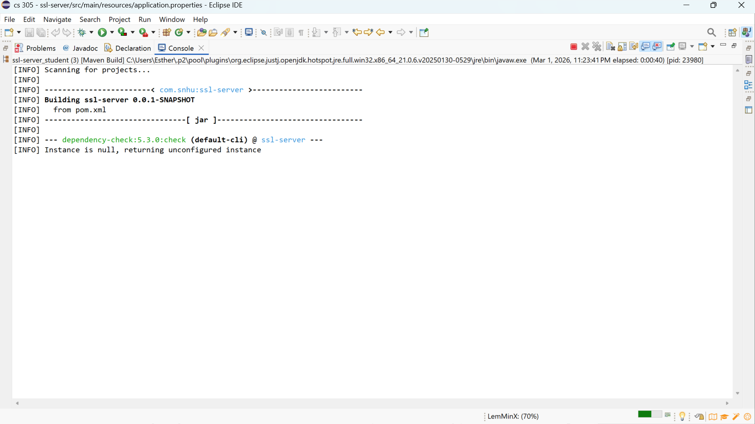

Functional Testing
Manual review and functional testing were performed to ensure the application compiled
and executed without syntax or runtime errors. After correcting SSL configuration issues,
the application successfully started and processed requests securely.

Summary

The application was refactored to improve data integrity and secure communications.
SHA-256 hashing, TLS encryption, certificate management, and dependency scanning
were implemented to align with secure software development standards.
These improvements protect client financial data, reduce exposure to vulnerabilities, and
demonstrate compliance with modern security best practices.

Industry Standard Best Practices

Industry standard best practices were applied throughout the refactoring process. These
include using modern cryptographic algorithms such as SHA-256 instead of deprecated
algorithms like MD5 or SHA-1, enforcing HTTPS with TLS encryption, and securely
storing cryptographic keys in a PKCS12 keystore.
Static analysis tools such as OWASP dependency-check were used to identify known
vulnerabilities in third-party libraries. Configuration management practices were
followed to ensure secure application settings, including proper SSL configuration and
avoidance of hard-coded secrets.
Applying industry best practices strengthens the organization’s overall security posture,
protects client financial information, reduces legal and compliance risks, and builds trust
with customers by demonstrating a commitment to secure software development.

